**Use case diagram**

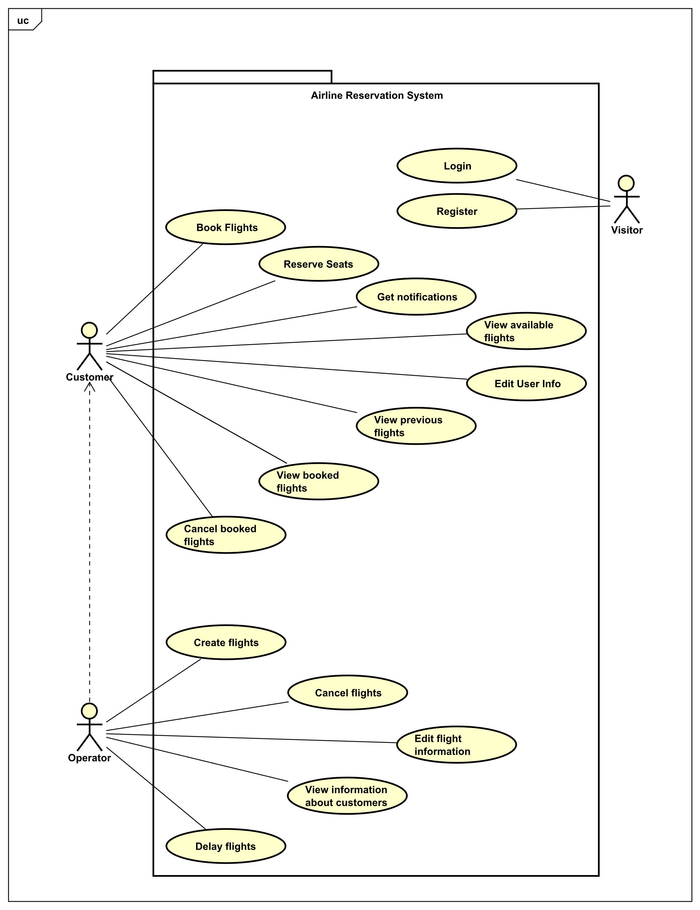

**Use case descriptions**

**Login**

|  |  |
| --- | --- |
| **Use case** | Login |
| **Summary** | Visitor log ins into the system |
| **Actor** | Visitor |
| **Precondition** | The customer already has an account registered |
| **Postcondition** | The customer is logged in the system |
| **Main scenarios** | 1. The visitor provides username and password  2. The system validates the customer’s username and password |
| **Alternative scenarios** | 2a The systems fails to validate credentials   1. The system signals an error and prompts for new credentials 2. The use case proceeds from (1) |

**Register**

|  |  |
| --- | --- |
| **Use case** | Register |
| **Summary** | The visitor signs up into library system |
| **Actor** | Visitor |
| **Precondition** | Visitor has a unique username, password, passport/id numbers and expiry date. |
| **Postcondition** | The visitor’s account was created, and visitor can log into the system as a customer |
| **Main scenarios** | 1. Visitors provides his/her information as a CPR, password, name, address and credit card information  2. System validates data  3. Visitor’s account was created |
| **Alternative scenarios** | At any time during step 1 visitor cancels  1. The use case ends  2a The account already exists  1. System informs visitor, that system already exists  2b visitor’s information are invalid  1. System informs visitor, that his/her data are not valid |

**Book flight**

|  |  |
| --- | --- |
| **Use case** | Book flight |
| **Summary** | The customer can book a flight |
| **Actor** | Customer |
| **Precondition** | Customer must be logged into their account and the flight must have available seats |
| **Postcondition** | The chosen flight is booked |
| **Main scenarios** | 1. The customer chooses the flight that they want to book.  2. The system shows details regarding the flight.  3. The customer books seats.  4. The customer selects what type of luggage they want to bring.  5. The customer purchases the ticket.  6. The system generates an unique code for the ticket purchase. |
| **Alternative scenarios** | At any time during step 1 customer cancels  1. The use case ends  3a The customer does not want to reserve desired seats  1. System chooses a random seat for the customer. |

**View available flights**

|  |  |
| --- | --- |
| **Use case** | View available flights |
| **Summary** | View flights available for customer |
| **Actor** | Customer |
| **Precondition** | Flights must be added by operator into the system and dates of the flights are in the future |
| **Postcondition** | Flights are viewed to the customer |
| **Main scenario** | 1. Customer inputs departure from 2. Customer inputs flight destination 3. Customer inputs departure date 4. System shows a list of all available flights with those constraints |
| **Alternate Scenario** | If there are no data stored, continue from 1.  If the system cannot find item with specific attribute, system will show an error message. |

**Get notifications**

|  |  |
| --- | --- |
| **Use case** | Get notifications |
| **Summary** | Customer gets notified by system |
| **Actor** | Customer |
| **Precondition** |  |
| **Postcondition** |  |
| **Main scenario** |  |
| **Alternate Scenario** |  |

**Cancel booked flights**

|  |  |
| --- | --- |
| **Use case** | Cancel booked flights |
| **Summary** | Customer cancels their booked flights |
| **Actor** | Customer |
| **Precondition** | Flight must be booked by the customer |
| **Postcondition** | Flight is no longer booked for the specific customer |
| **Main scenario** | 1. Customer views booked flights 2. Customer selects the booked flight to be cancelled 3. Customer cancells the flight 4. System shows confirmation prompt 5. Customer will confirm that the customer wants to cancel that particular booked flight 6. System will notify user that the flight is no longer booked 7. System will delete booked code, generated for customer |
| **Alternate Scenario** | *a At any time during step 1,2,3 & 4 Customer cancels  1. The use case ends |

**Edit user info**

|  |  |
| --- | --- |
| **Use case** | Edit user info |
| **Summary** | The customer manages their account |
| **Actor** | Customer |
| **Precondition** | Customer must have account |
| **Postcondition** | Changes made by customer are saved |
| **Main scenario** | 1. The customer chooses to change the value for:   a. Full name  b. Password  c. Address  d. Date of birth  e. Passport/Id number  f. Passport/Id expiration date  g. Nationality  h. Gender  i. Phone number  j. Email address  k. Credit card info   1. System will confirm that info has been edited |
| **Alternate Scenario** | 1a The entered value is the same as previous value  1.No change has been made |

**View booked flights**

|  |  |
| --- | --- |
| **Use case** | View booked flights |
| **Summary** | The customer views booked flights |
| **Actor** | Customer |
| **Precondition** | Flight must be booked by customer in Book flights and the flight did not happen yet |
| **Postcondition** | Flights are shown to a customer |
| **Main scenarios** | 1. Customer open booked flights 2. Booked flights are shown |
| **Alternative scenarios** | If there are no booked flights, system will show an error |

**View previous flights**

|  |  |
| --- | --- |
| **Use case** | View previous flights |
| **Summary** | The customer views booked flights |
| **Actor** | Customer |
| **Precondition** | Flight must be booked by customer in Book flights and the flight already happened |
| **Postcondition** | Previous flights are shown to a customer |
| **Main scenarios** | 1. Customer open booked flights 2. Previous flights are shown |
| **Alternative scenarios** | If there are no previous flights, system will show an error |

**Create flights**

|  |  |
| --- | --- |
| **Use case** | Create flights |
| **Summary** | The operator creates a new flight |
| **Actor** | Operator |
| **Precondition** | Operator must have all details about new flight |
| **Postcondition** | The flight is created |
| **Main scenarios** | 1. The operator chooses to create new flight  2. The operator needs to insert information about flight  3. The system validates data of the new flight  4. The flight is created and stored in the database |
| **Alternative scenarios** | 2a The flight information is invalid   1. System informs operator, that information is invalid |

**Cancel flights**

|  |  |
| --- | --- |
| **Use case** | Cancel flight |
| **Summary** | The operator cancel flight |
| **Actor** | Operator |
| **Precondition** | Flight must be created in database |
| **Postcondition** | The flight is cancelled |
| **Main scenarios** | 1. The operator chooses an upcoming flight to cancel  2. Flight is cancelled |
| **Alternative scenarios** | If flight already happened, system will show an error |